Bridges For Brain Injury Program Supplies Wish List

- Hand Sanitizer
- Paper Towels
- Coffee & Creamer & filters
- Napkins
- Sandwich bags, plastic wrap and/or tinfoil
- Gloves (Med/Large)(non-latex)
- Sugar/Sweet & low packets
- Hand Soap
- Soap & Sponges
- Garbage Bags
- Laundry Detergent
- Cleaning Wipes
- Windex
- Bleach or other disinfectant cleaning spray
- Dishwasher soap
- Kitchen Towels
- Silverware
- Utensil carousel
- Gift Cards to Lowe’s, Home Depot, Target, TOPS, Wegmans, Dollar Tree, Gas Stations
- New or used vehicle, van, mini-vans
- Art & Craft Supplies
- Copy paper
- Dry erase markers & erasers
- Printing service
- Magazine Subscriptions
- Discounted/free tickets to sporting events, amusement parks, museums, movies, concerts, theatre, bowling, etc….
- Gardening Tools, Cart, Potting Bench
- 8x12 Polycarbonate Greenhouse
- Silent Auction Donations
- Cans & Bottles For Recyling
- New or Gently used household items, clothing, gifts, etc… for our Member Holiday Auction
- Volunteers To Share Skills with Program Members (Art/Crafts, Yoga, Cooking, Woodworking, etc..)
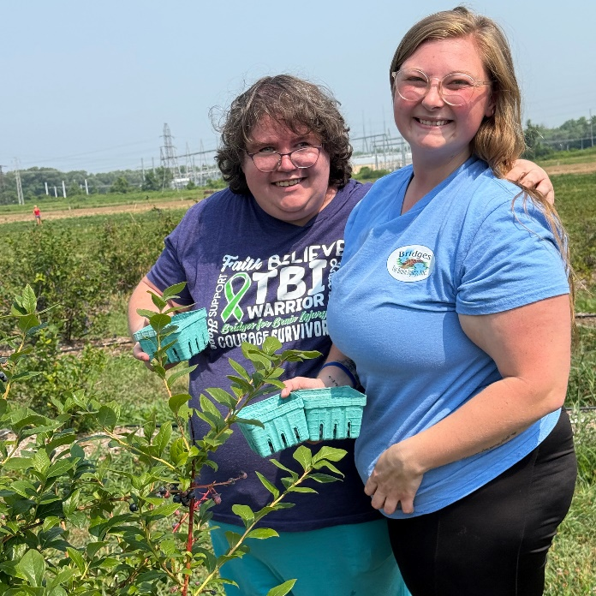
- Volunteers passionate about helping others who would like to serve on a committee or our Board of Directors.
- Heavy duty arm chairs
- Plastic 12 oz plastic dishwasher safe cups
- Plastic dishwasher safe plates

